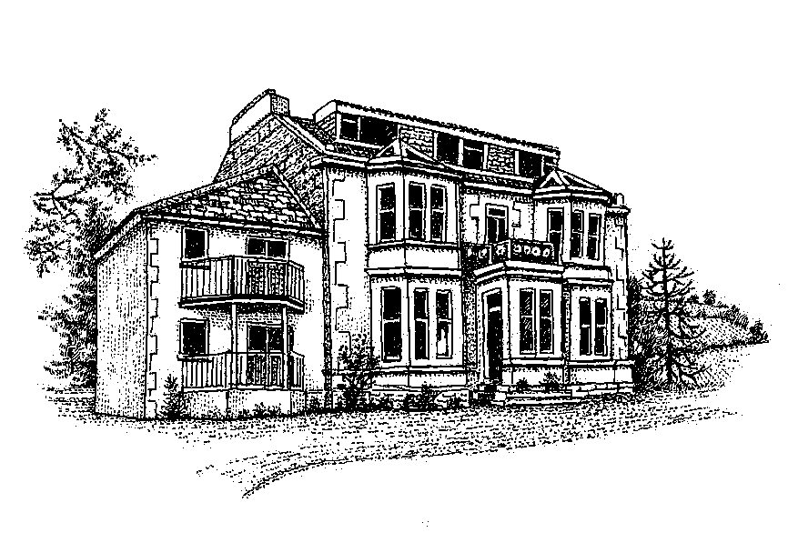
‘Kinneil’
Lamlash
Isle of Arran
KA27 8JT
Tel: - 01770 600307
BOOKING FORM FOR KINNEIL SELF CATERING APARTMENTS
(Please complete a Booking Form for each apartment)

Apartment……………… Dates of Holiday: From………To: …………

Full names and titles of all guests, including infants, who will be staying in the apartment during the rental period.
Please state ages if under 12 yrs of age:

………………………. ………………………….. ………………………. .. ………………………………

……………………… …………………………… …. ……………………... ………………………………

How did you hear about Kinneil? Our own Website: ‘www.kinneil.co.uk; Internet Guide to Scotland Website;
Visit Scotland Website; Tourist Board; Personal recommendation; other?

…………………………………………………………………………………………………………………………..

Name and address for correspondence: ……………………………………………………………………………...

…………………………………………………………………………………………………………………………...

Purpose of Visit: Relaxation; Walking; Climbing; Cycling; Golfing; Other?.........................................................

Contact tel. number: …………………………………… Mobile number: …………………………………………

E-mail address:…………………………………………………………………………………………………………

Car make(s) and registration number (s) :…………………………………………………………………………...

Names of any smokers in your party.........................................................................................................................................

Time of arrival if known at this stage: ……………………………………………….(N.B. see clause 5 overleaf)

Please find enclosed my deposit/full rental of:………………………………………………………………………

I agree that my booking will be subject to the Conditions of Let as shown overleaf

Signature of Person booking on behalf of the party ……………………………………..Date…………………….

Name in Block Capitals………………………………………………………………………………………………..

Cheques to be made payable to ‘Kinneil’ and posted to the above address

E-mail: kinneil@btinternet.com
www.kinneil.co.uk

N.B. Kinneil is a strict non-smoking establishment
We do allow pets/animals by prior arrangement in some apartments

CONDITIONS OF LET

- Holiday cancellation insurance is not included in the rental and should you have to cancel your booking, a refund will be made, only if the accommodation is re-let for the period concerned. If successful, the deposit and balance, if paid, will be refunded less a £20 re-booking fee. A written cancellation must be notified to the Management at Kinneil prior to the commencement date of the holiday.

- The Management reserves the right to cancel a holiday, and withhold the deposit, if the information given by the applicant is found to be false prior to the commencement of the holiday

- A Security of £75 per booked apartment is payable in cash on the day of arrival and will be refunded within seven days of your departure, by cheque, sent by First Class Post, subject to clauses (8), (10) and (11) below.

- Where a booking has not been made the full rental and Security is to be paid in cash on the day of arrival.

- The period of the let shall be from 1600hrs on the day of arrival to 1000hrs at the latest on the day of departure. Departures after 1000hrs will be subject to an extra half-day’s rental.

- Weekly rentals will commence on a Friday, or Saturday unless otherwise agreed with the Management.

- The contract confers on you the right to occupy the accommodation for a holiday only and, in terms of section 12 (schedule 4, paragraph 8) of the Housing (Scotland) Act 1988 is not an ‘assured tenancy’.

- The applicant must personally stay at the accommodation throughout the holiday and is solely responsible for the whole party. Assignees and sub-tenants are prohibited. No more than the stated number and named guests, as shown on the Booking Form, may stay at the property. If an invitee (not shown on the Booking Form) wishes to join your party, after the commencement date of the holiday, the permission of the Management must be obtained, which will be subject to safety requirements and maximum capacities. A cash rental will be charged on a ‘per person per night’ basis. The Management reserve the right to deduct monies to the equivalent rental, from the Security, if it is found that a guest/guests is/are staying in contravention of this clause.

- A deposit of 40% of the full rental is payable within one week of booking. The balance of rental is payable six weeks before the commencement date of the holiday.

- Please ensure that you take all reasonable care in the use of the property and its contents, including the security of the property and to report any damages, losses, or breakages as soon as they occur.

- You are requested to leave the accommodation, as you would wish to find it. The Management reserves the right to charge for losses, damages, breakages, and extra cleaning, if the accommodation is left in an unsatisfactory condition, and the cost will be deducted from the Security money. The applicant will be responsible for the payment of any costs, over and above, the £75 security deposit.

- As far as the law allows, the Management takes no responsibility for loss, damage, or injury to you or any of your party, as a consequence, of this agreement, or the occupancy following thereon.

- You will indemnify the Management against loss, damage or injury sustained to the property or persons as a result of any breach of these conditions or arising from fault of you or any member of your party

- The brochure is as accurate as possible but cannot be warranted, nor do the descriptions form any contract. The Management reserves the right to alter or improve any of the subjects without notice.

- The Management reserves the right to enter the accommodation at any reasonable time.

- The Management reserves the right to change prices at any time, except in the case of confirmed bookings.

- Kinneil is a Non-Smoking establishment. If it is found that a guest, or guests is/are in contravention of this requirement, the Management will require the guest(s), and party, to vacate the premises forthwith and no monies will be refunded. The £75 Security will be withheld to cover any remedial costs.

- The Management does not allow animals or pets to stay at Kinneil, to include those belonging to guests’ visitors, with the exception of assistance dogs.
Your signature on the booking form confirms acceptance of these conditions, so please ensure you read them carefully before making your booking.

